# A. MANAGING DIRECTORIES

1. Change the current directory to /home*/<user>*

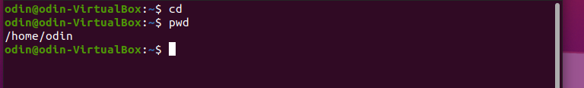

1. Create a directory called **systems**

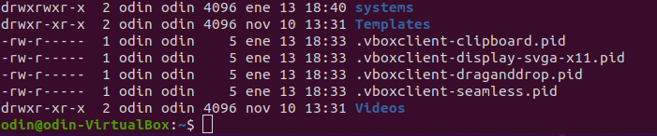

1. Create a directory called **exercises**. Go to this directory and create another new directory called **programming**

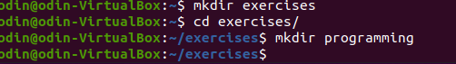

1. Go back to the user’s home directory. Delete the directories “exercises” and “programming” using just one command. Create the directories again with one command.



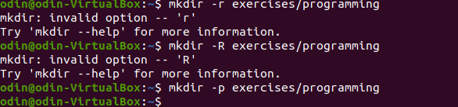

1. Print the contents of the root directory

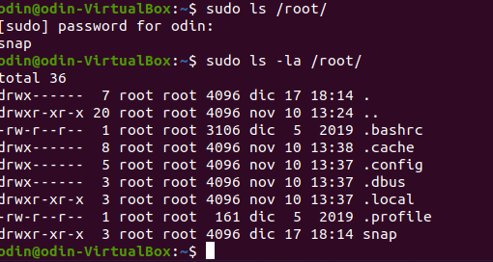

1. Print all the files and directories that begin with d in the /usr/bin directory

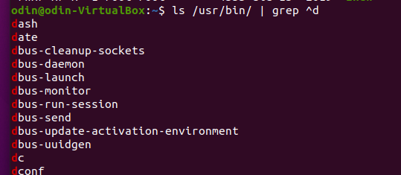

1. List all the files and directories in /etc, including subdirectories

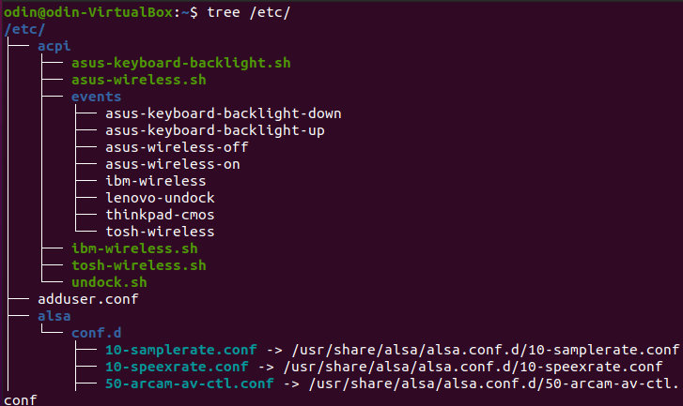

1. Create the empty files called student.txt, student1.txt, student2.txt, list, luggage and last in the directory named “systems”

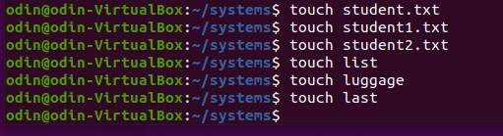

1. Print all the files that begin with “l” in the directory “systems”

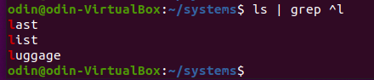

1. Print all the files that end with “txt” in the directory “systems”

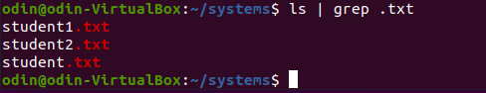

1. Create a new directory into $HOME called “config”



1. Copy all the files in /etc which begin with “a” into “config”



1. Delete all the files in “config” which end with “conf”



# B. COPY, RENAME AND EDIT FILES

Create the following directory structure in /home/<user>/exercises

exercises

Africa

Asia

Tunisia Egypt Seul Laos

1. Create the following files using **nano** (or another editor):

**song.doc** (write a few lines of a song) in the directory **Egypt**;

**tv.doc** (write the name of your favourite TV programs) in the directory **Seul** and

**marks** (write the marks you expect to get this year) in the directory **Tunisia**.

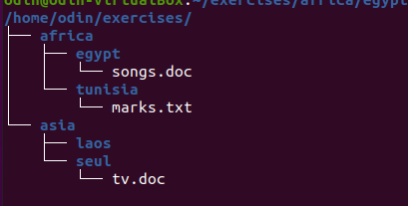

## CHANGE THE CURRENT DIRECTORY TO AFRICA AND DO THE FOLLOWING EXERCISES USING RELATIVE PATHS

1. Copy the file “song.doc” into “Laos”



1. Copy the file “tv.doc” into “Egypt” with the name “radio.txt”



1. Rename the file “marks” to “exam.wri” (it is located in the directory named Tunisia)



1. Copy the file “song.doc” (located in “Egypt”) inside “Tunisia”



1. Print the content of the current directory using long listing format

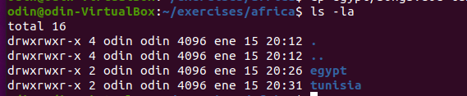

1. Rename the file “song.doc” (located in “Laos”) to “aa.doc”



1. Create the directory “Others” in “Laos”



1. Rename the directory named “programming” (which you created in the first exercises) to pro-c.



1. Create the following directory tree in “exercises” (using as few commands as possible)

### ONE

TWO THREE 

1. Move the files you copied in the exercise above to the directory THREE.



1. Delete the directory named THREE, including all the files and, if so, subdirectories



## CHANGE INTO SYSTEMS AND DO THE FOLLOWING EXERCISES USING ABSOLUTE PATHS

1. Copy the files that end with “txt” of the directory named “systems” to “Tunisia”



1. Copy the file “tv.doc” (located in “Seul”) to the directory named “exercises”



1. Rename the file student1.txt (located in “Tunisia”) to tuition.txt



1. Create a new directory called “earth” into “systems”. Create another directory called

“countries” inside “earth”



1. Rename “Africa” (located in “exercises”) to “Afri”



## NOW YOU CAN BE PLACED IN THE DIRECTORY YOU WANT

1. Move the file “song.doc”, which is located in Egypt, to “Laos” with the name “bb.doc”



1. Copy the files whose name contains the letter “u” from “systems” to “exercises”

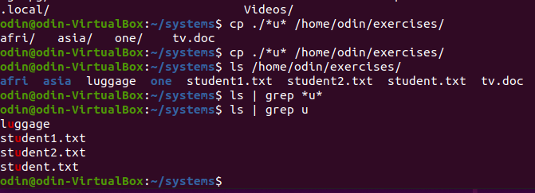

1. Print the content of the /etc directory, including subdirectories, in reverse alphabetical order

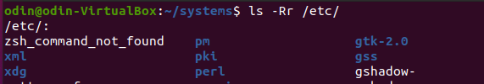

1. How can you print the name of the current directory?

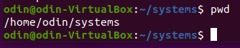

1. Copy the folder “Afri” including files and subdirectories to “Asia”



1. Move all the files and subdirectories of “Laos” to “Seul” and rename it to “Seul2”

